Aim: To understand burp proxy to test web application

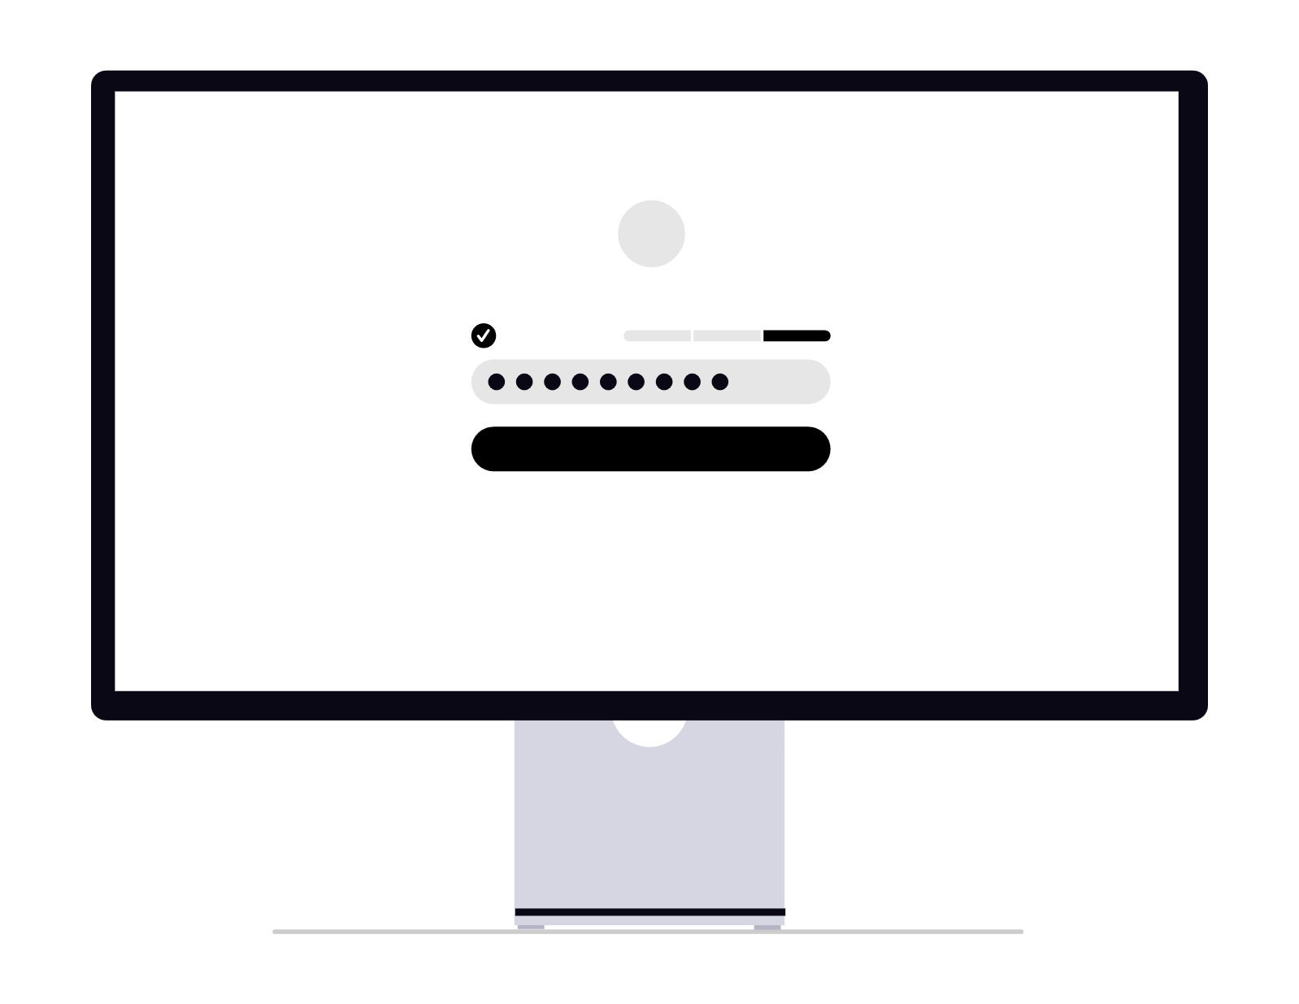
Burp Proxy acts as a man-in-the-middle (MITM) proxy between the client (browser) and the web server.
It intercepts all HTTP/HTTPS requests and responses, allowing the tester to pause, inspect, and modify traffic in transit.
This breaks the standard client-server direct communication model, enabling controlled manipulation of input/output for security evaluation.

Feature | Description
Intercept | Pauses requests/responses before they reach their destination. Tester can edit headers, parameters, cookies, and body content.
Forward | Sends the modified or unmodified message to its intended recipient (server or browser).
Drop | Discards the intercepted message, preventing it from reaching the target.
HTTP History | Logs all proxied traffic for later review, comparison, and analysis.
Repeater | (Optional extension) Allows manual resending of requests with custom modifications for repeated testing.

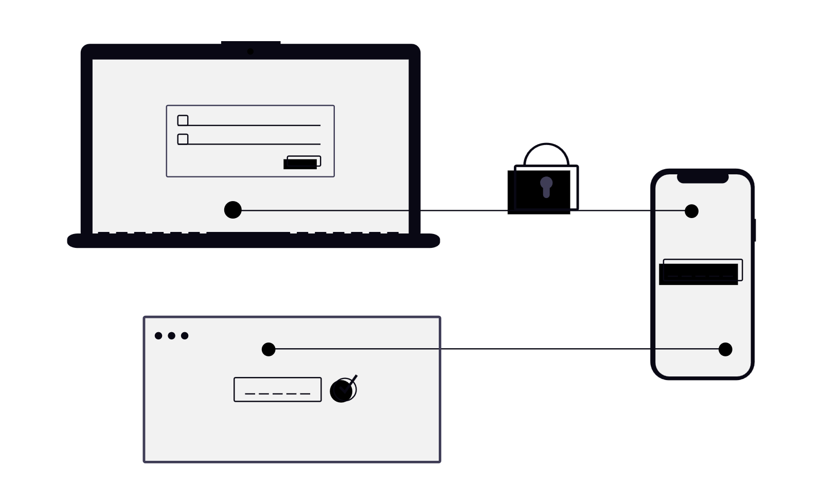
Advantages of Using Burp Proxy
- Full control over request/response lifecycle
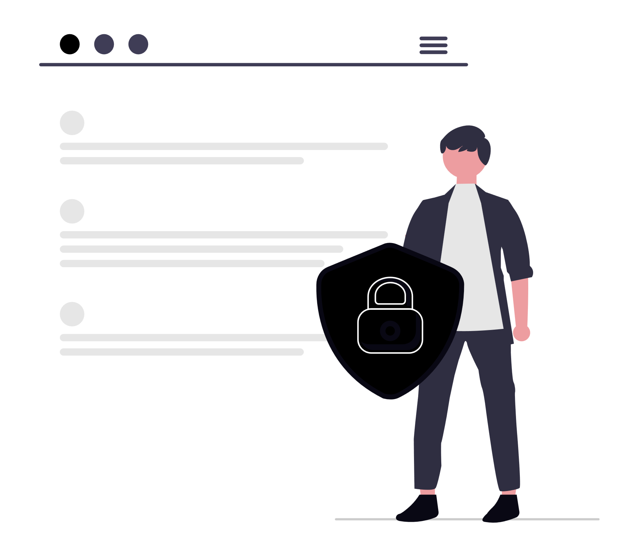
- Real-time modification without re-generating traffic from the client
- Supports both HTTP and HTTPS with proper certificate setup
- Integrates with other Burp tools (Scanner, Intruder, Repeater) for advanced testing

Limitations
- Requires proxy configuration on the client side (browser or system)
- HTTPS interception may trigger certificate warnings unless the Burp CA is trusted
- Encrypted traffic (e.g., HSTS, pinned certificates) may block interception unless properly bypassed

Burp Proxy supports multiple interception modes to suit different testing scenarios:
Mode | Behavior
Intercept on | All requests/responses are paused for manual review and modification.
Intercept off | Traffic flows normally but is still logged in HTTP History.
Automatic modification | Rules can be defined to automatically modify headers, parameters, or body content without manual intervention.
Targeted interception | Only requests matching specific URL patterns, methods, or MIME types are paused.

Burp Setup

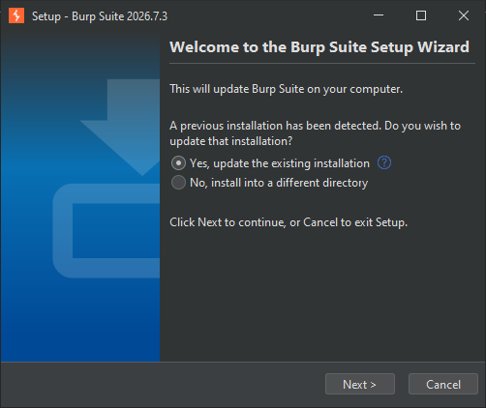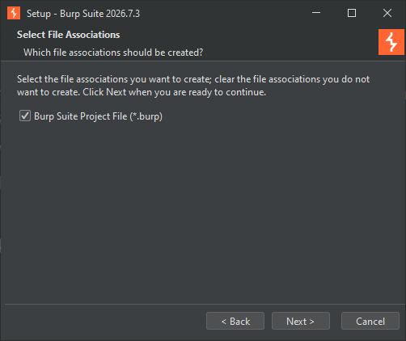
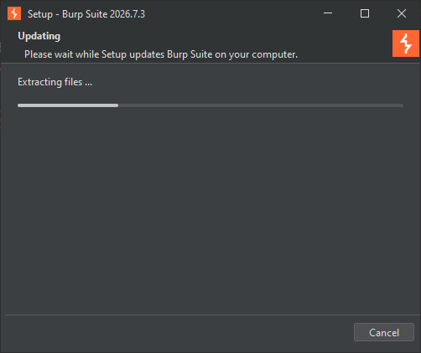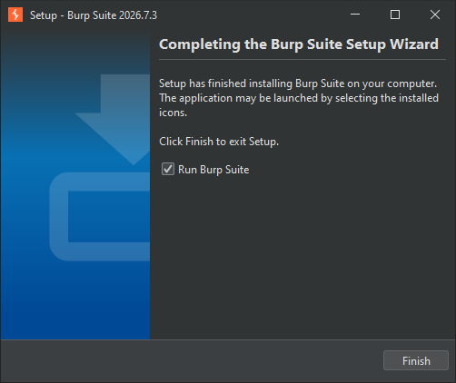

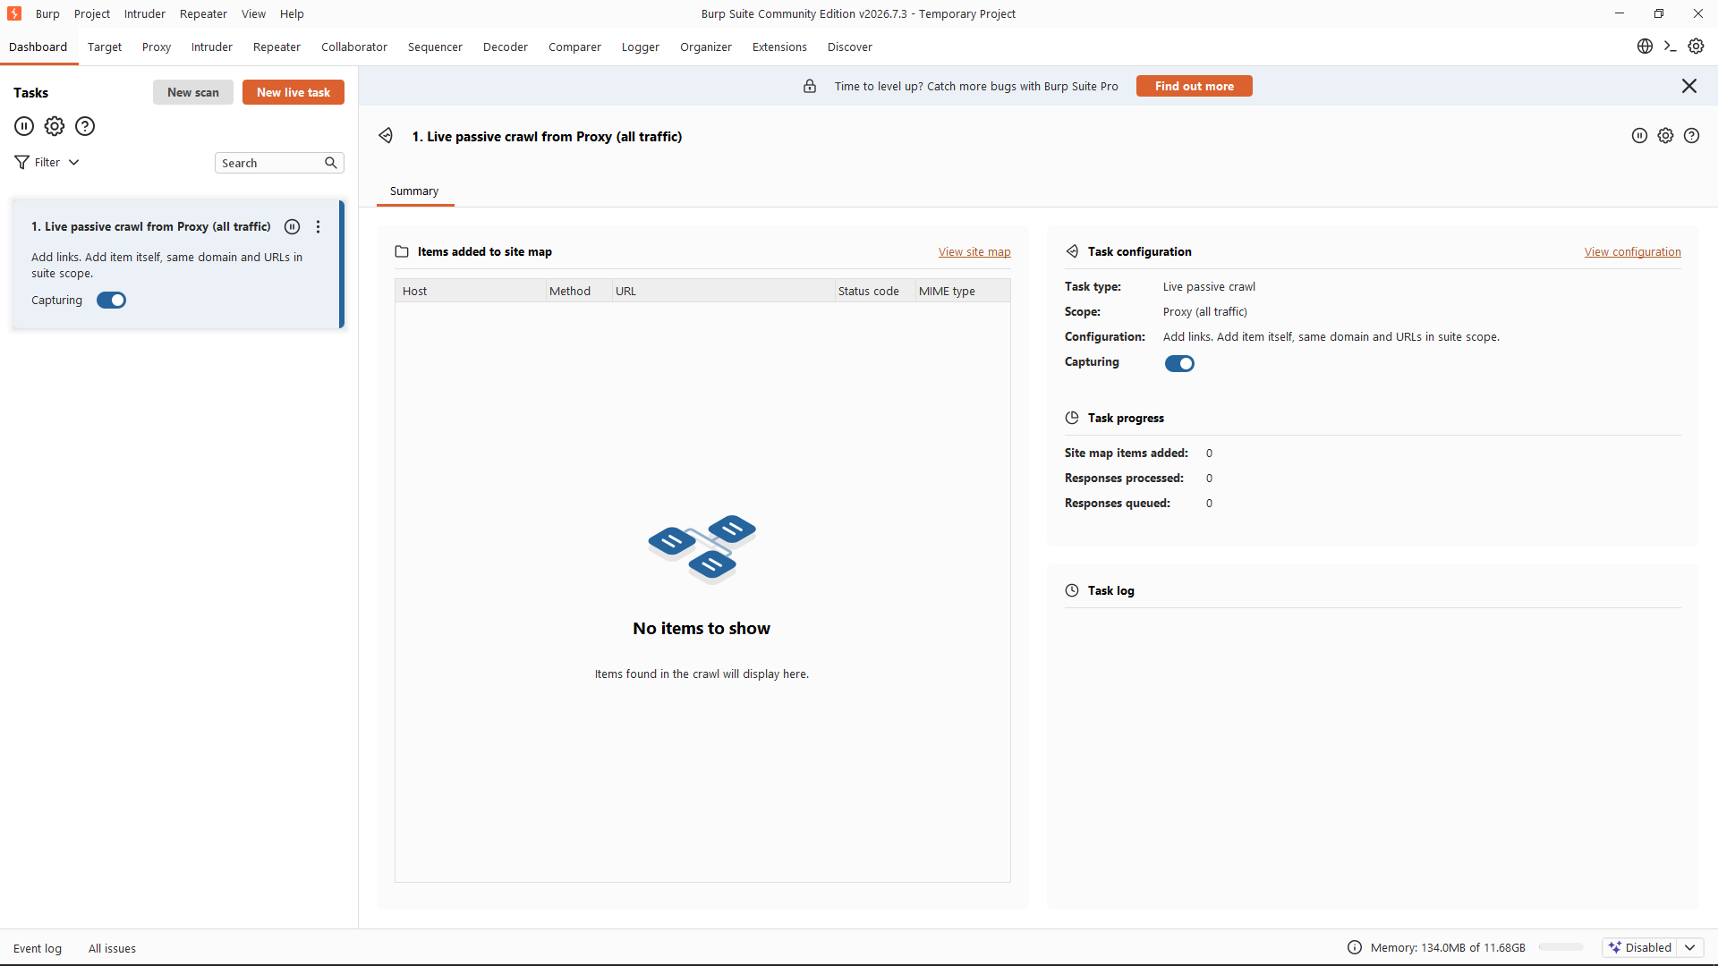
Burp Suite Dashboard

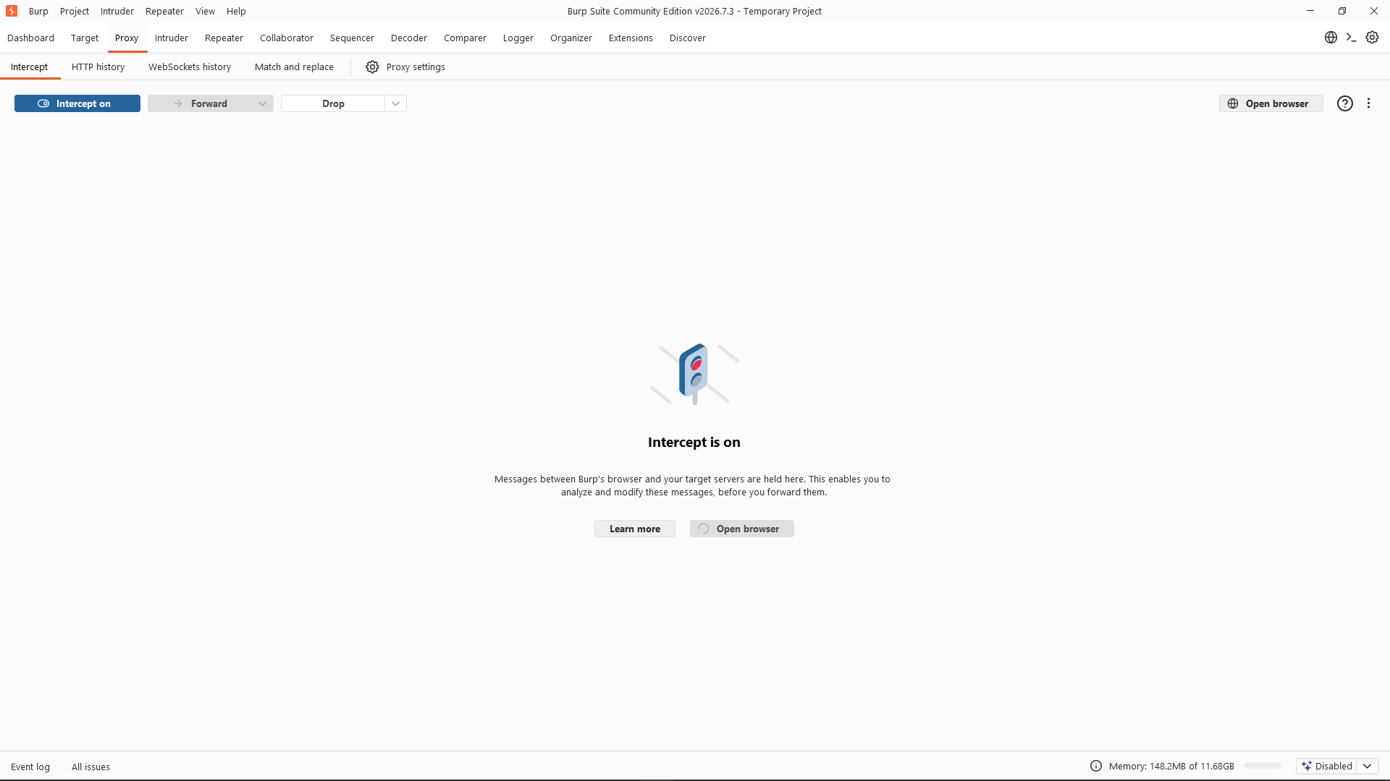
On ‘Proxy Intercept’ Page

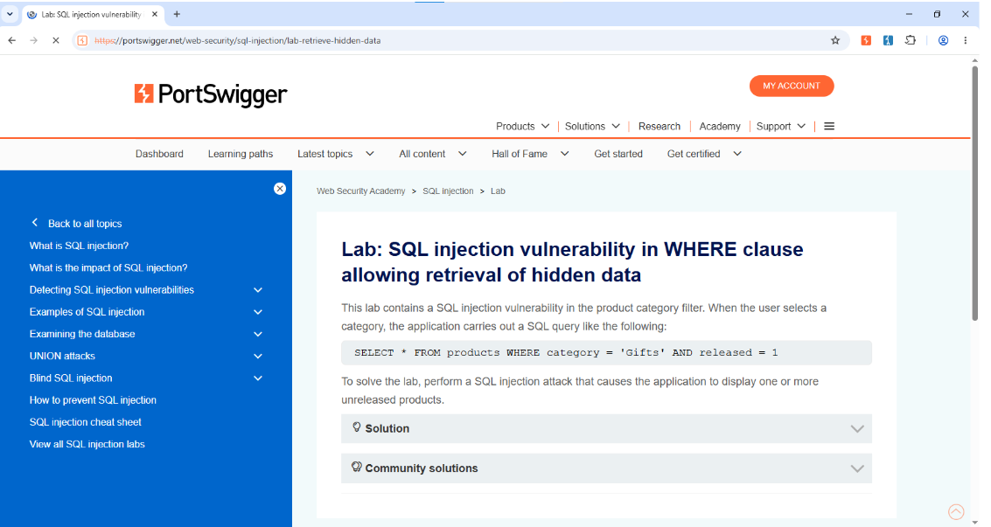

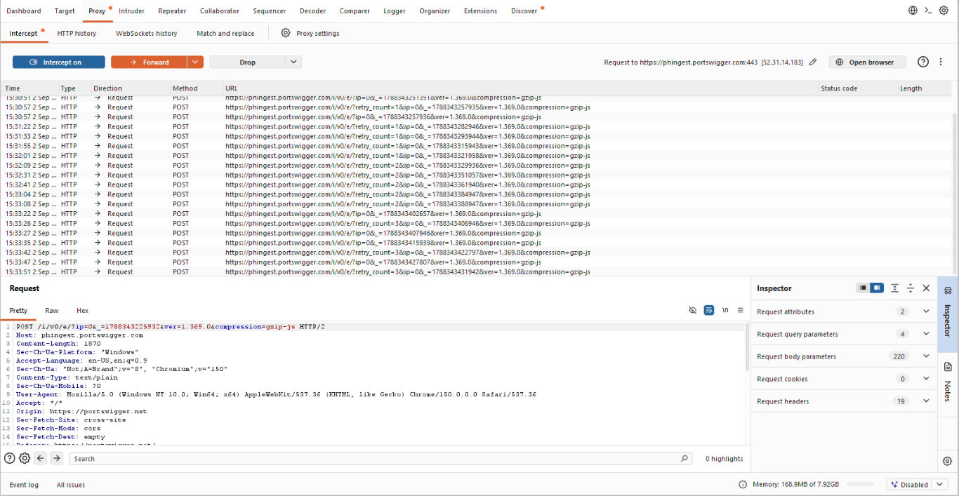

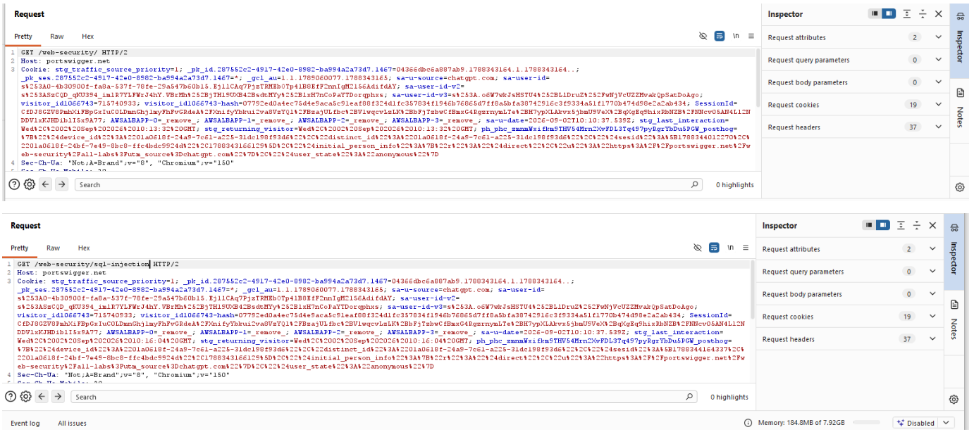

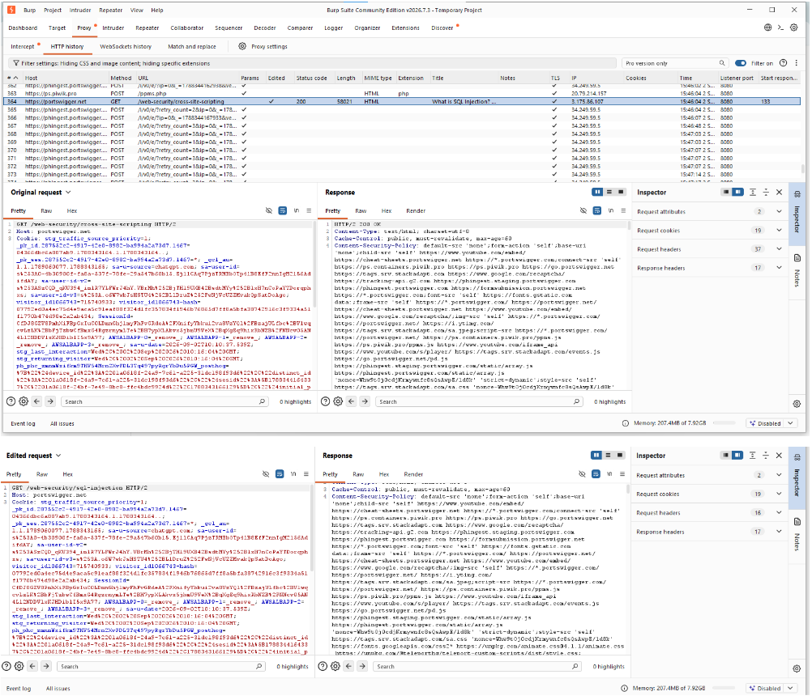

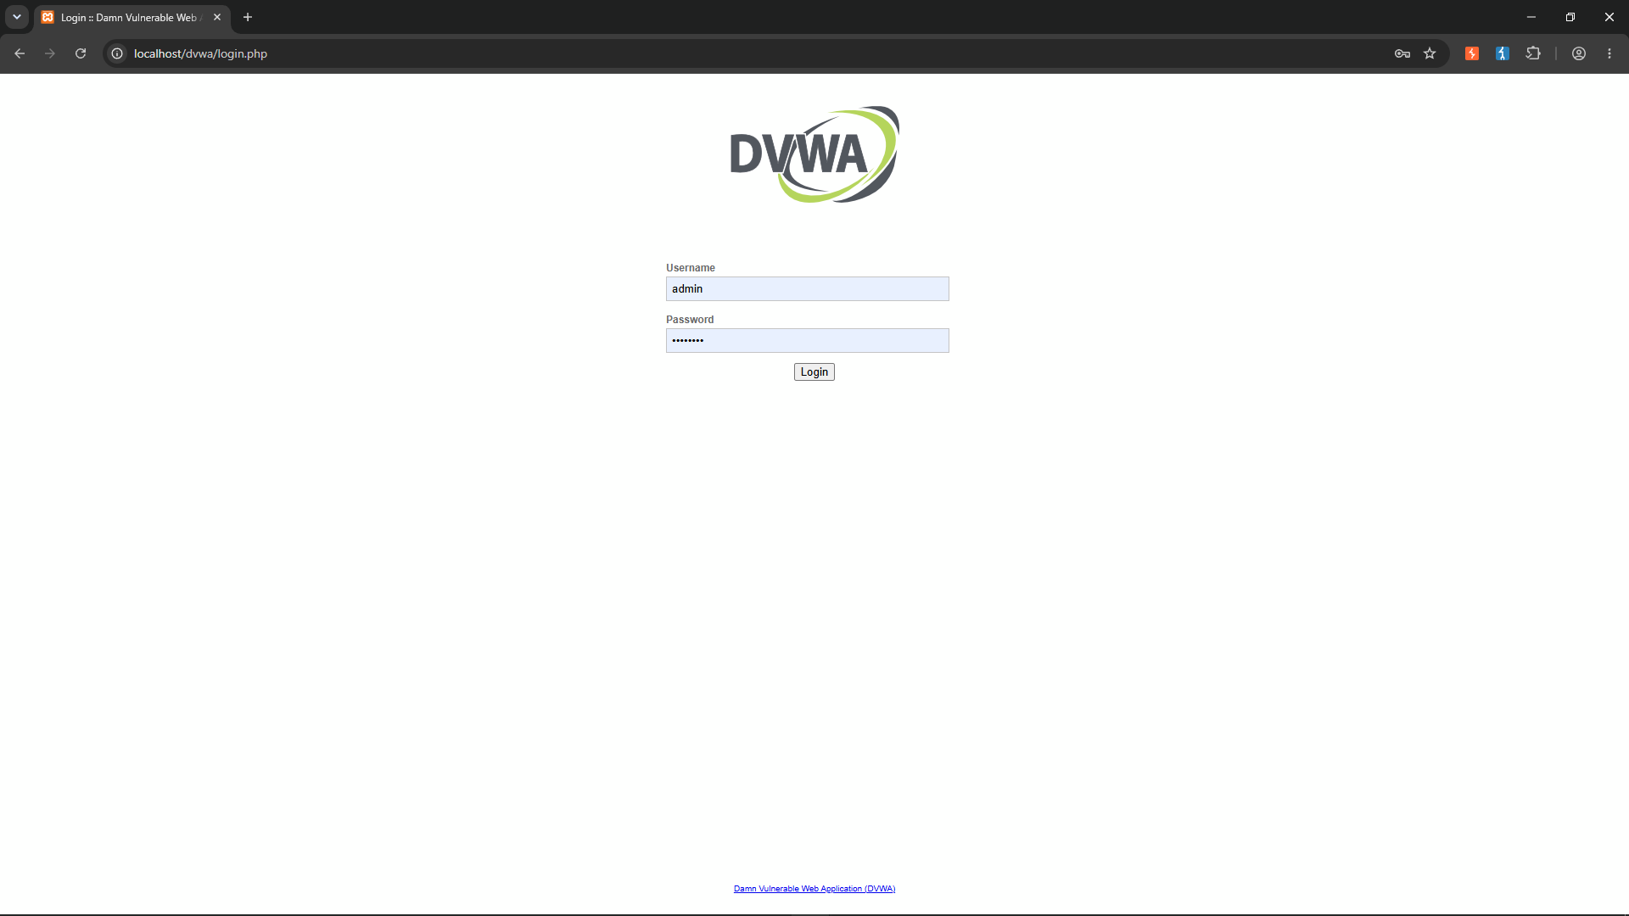
Inside Burp Suite browser logging into DVWA

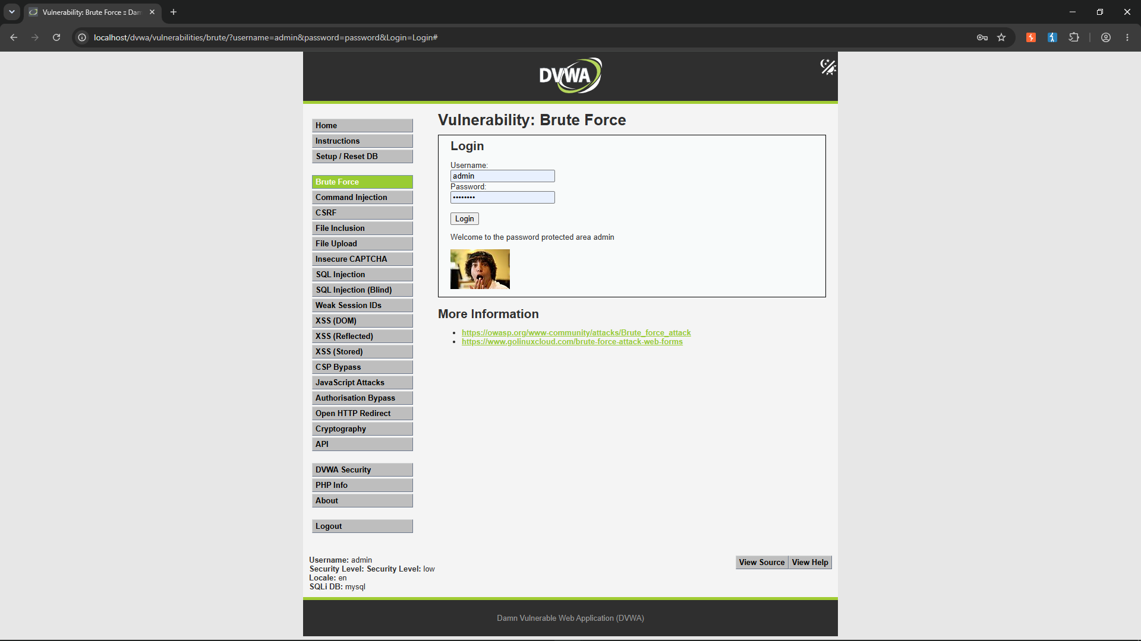
Demonstrating Correct credentials output (An image is shown if correct)

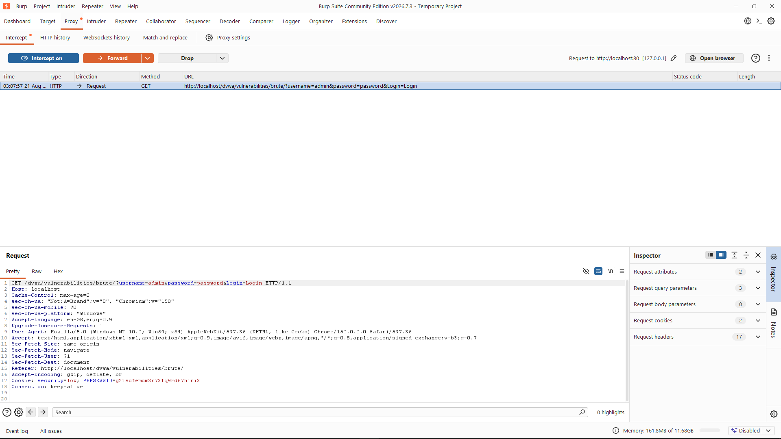
Received the sent credentials

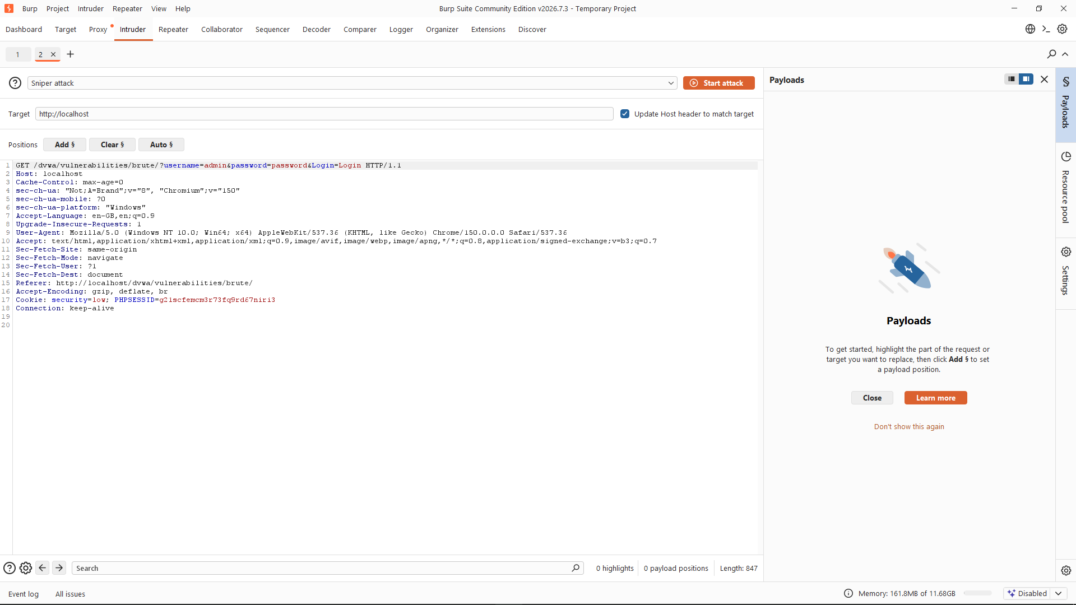
Acquiring username and password keys from the received URL

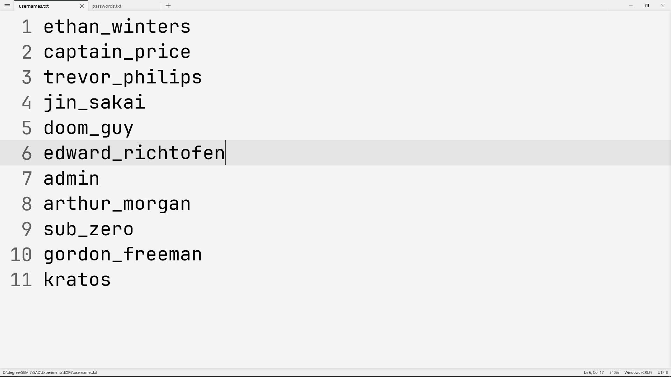
Cluster bomb list of usernames

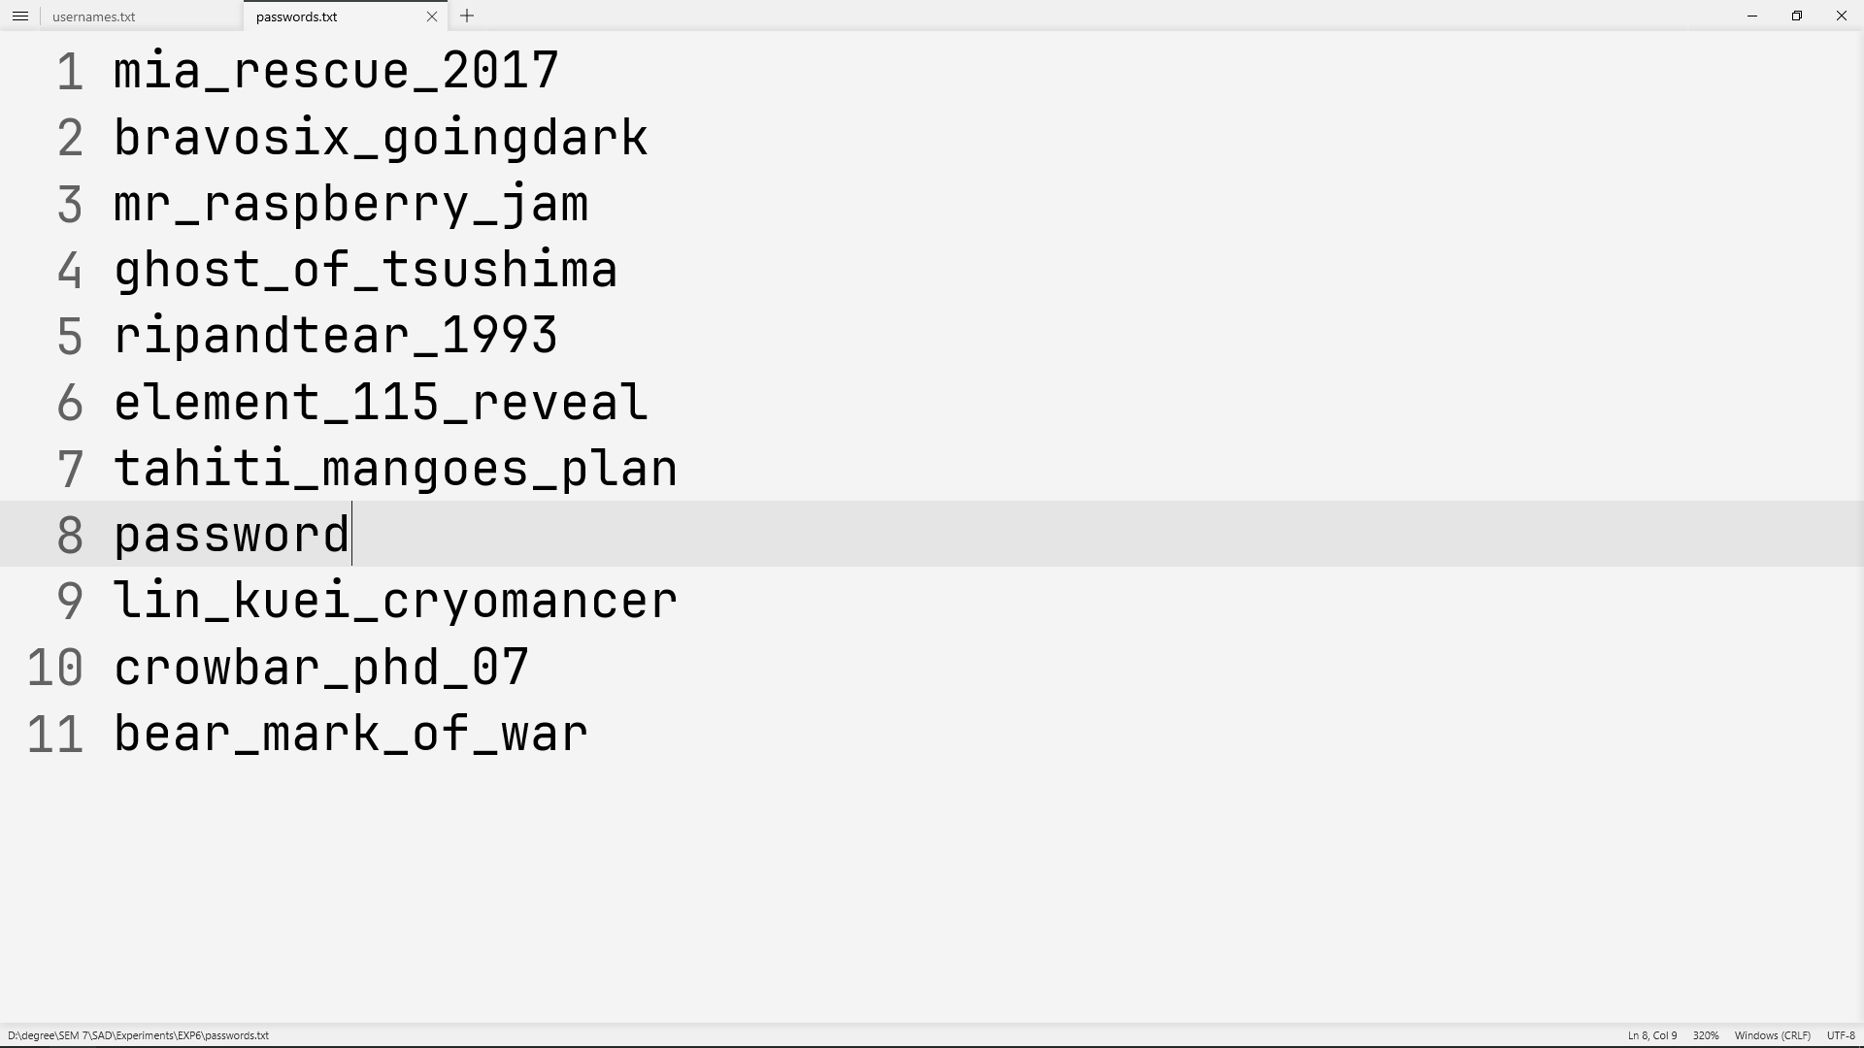
Cluster bomb list of passwords

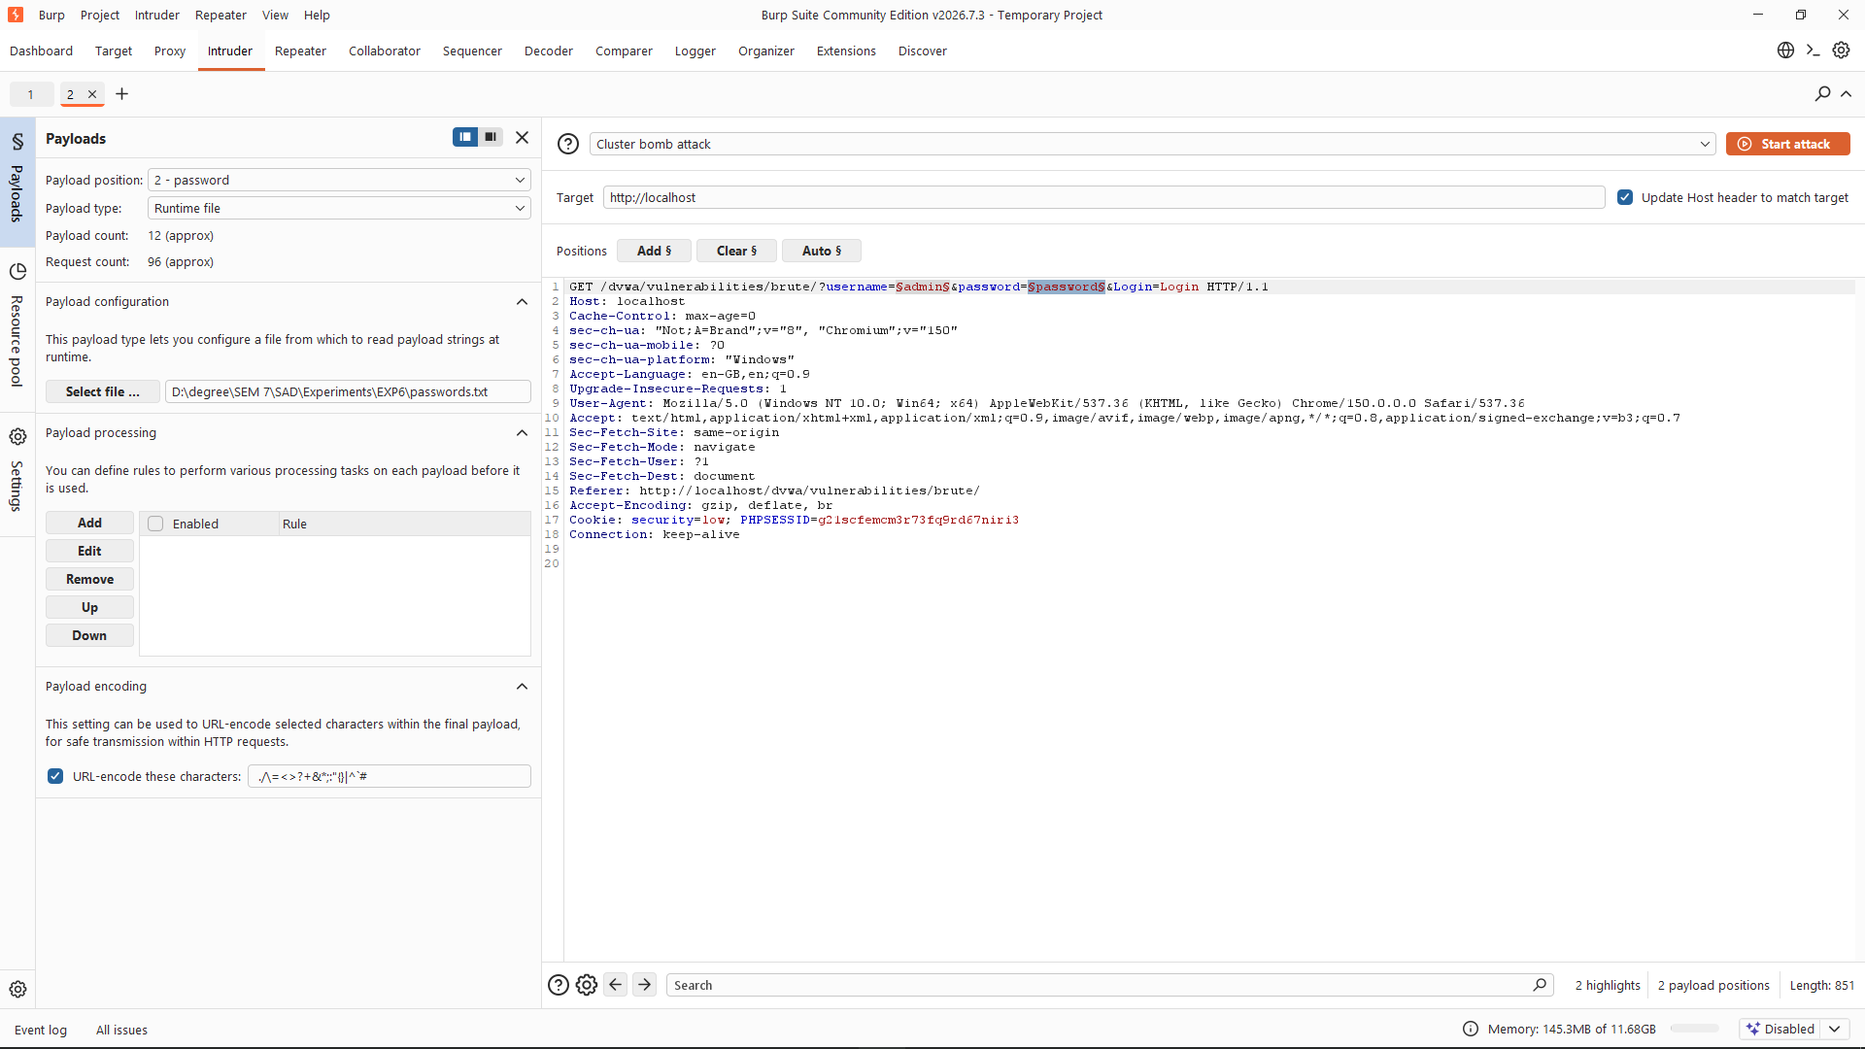
Attaching the username and password textiles to begin the attack

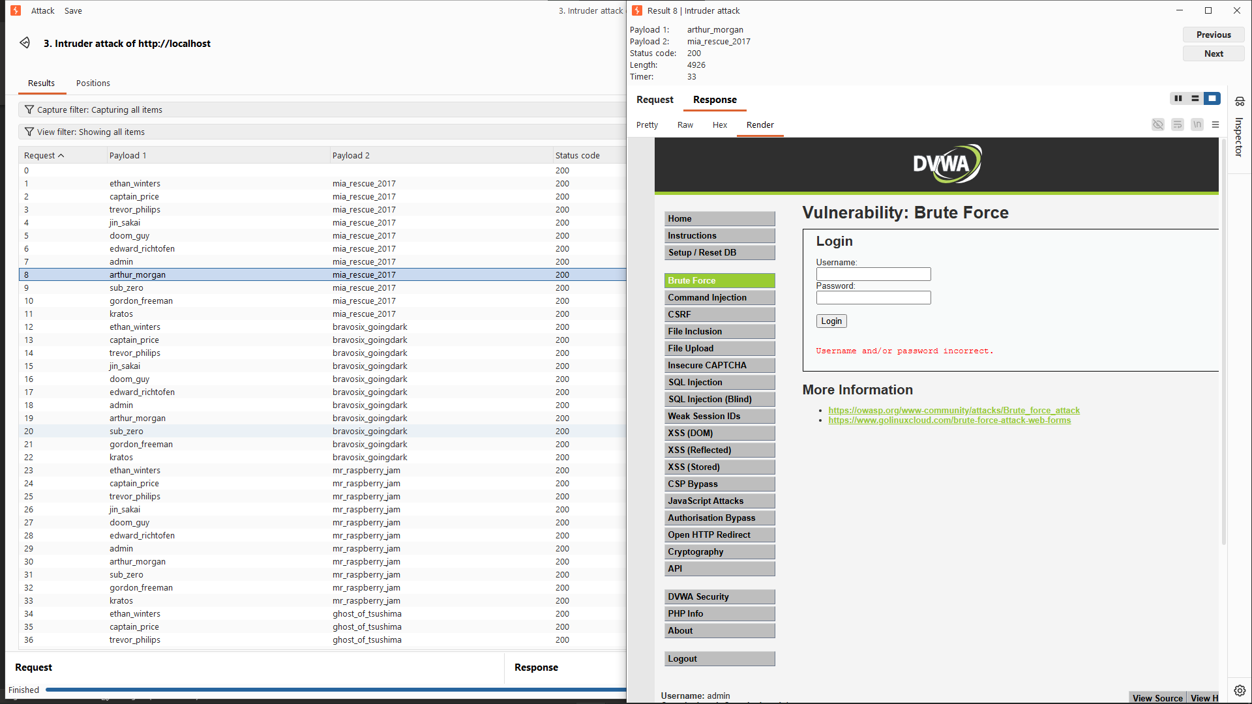
When incorrect username and password (The image is not shown)

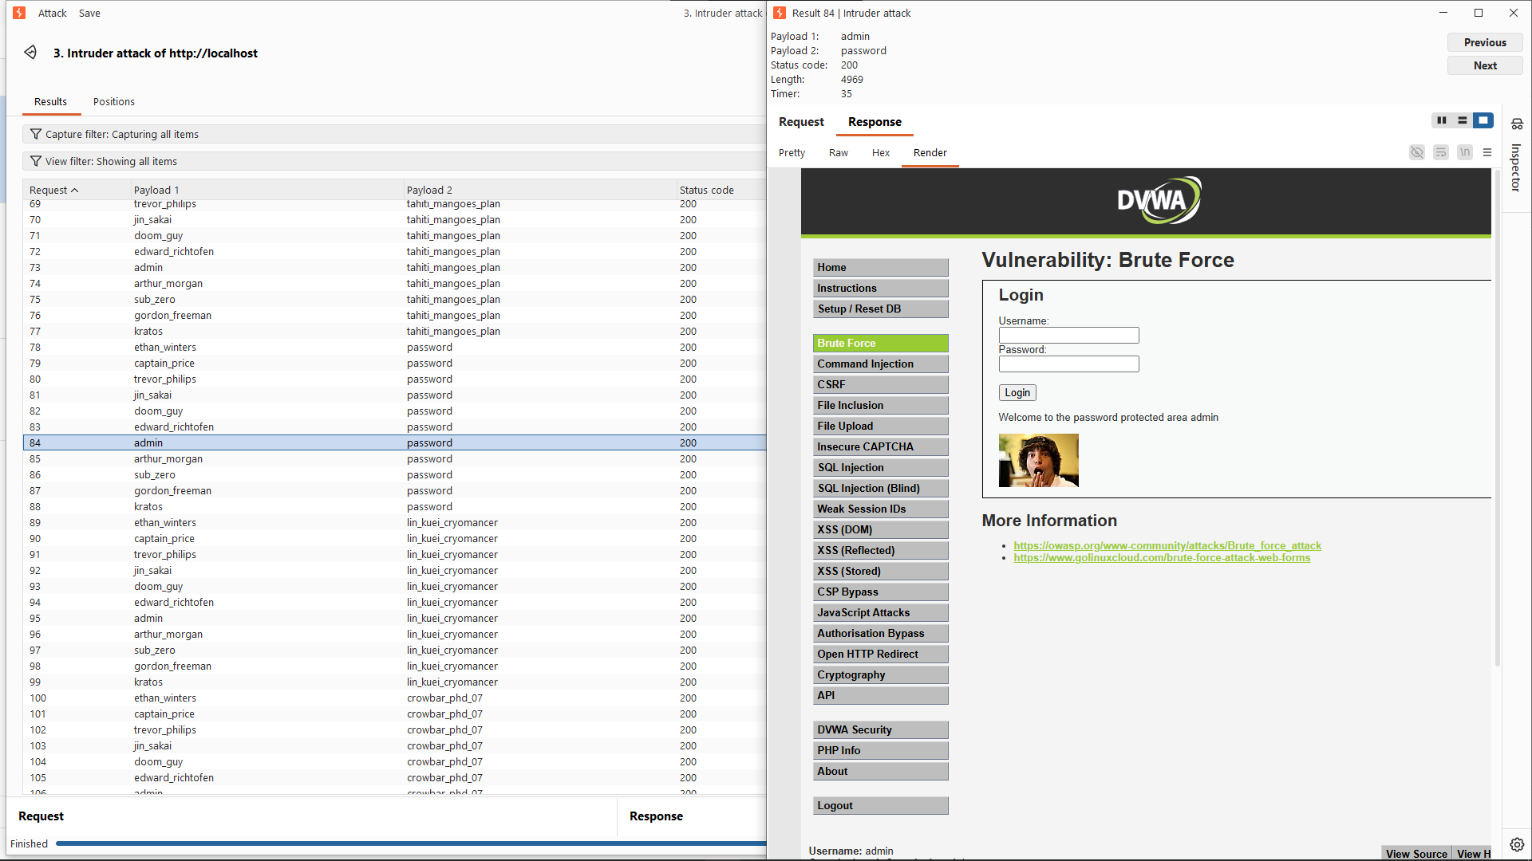
Correct username and password (The image is shown)

Conclusion
Burp Proxy was successfully used to intercept and inspect web application requests. The requests were modified and forwarded to understand how the application responds to different inputs.

